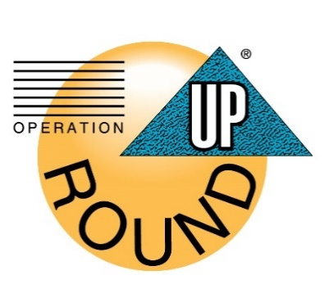
Operation Round Up is a voluntary program in which Oneida-Madison Electric Cooperative members can choose to round up their bill to the next whole dollar each month in order to help those in need. Example: if your monthly bill is $67.49, it would be rounded up to $68. Your monthly contribution could be as little as a penny, but never more than 99 cents.
The money raised is given to a charity of the members’ choosing that is voted on at the Annual Meeting each October.
In addition to the roundup feature, you have the flexibility to make a one-time donation of any amount you prefer or set up a recurring monthly donation at your chosen level.
To enroll, you may sign up via SmartHub or simply fill out the bottom of this form and the office staff will enroll your account on your behalf. You can cancel your enrollment at any time.

Operation Round-Up Enrollment Form
Sign me up for:
□ Operation Round Up (rounding your bill to the next nearest dollar)
□ One-time donation of $_______
□ Monthly recurring donation of $_______
Name: _____________________________________________________
Service Location: ______________________________________________
__________________________________________________________
Account number(s): ____________________________________________
Signature: __________________________________________________

FOR OFFICE USE ONLY
Added by: ___________________________ Date: ____________________

